App Name: Trip Planner

Tagline: From weekend getaways to business trips to family vacations, this is the one app you need to stay organized with whatever trip you take.

Repo Link: https://github.com/jamesylgan/hack_challenge_backend

Screenshots:

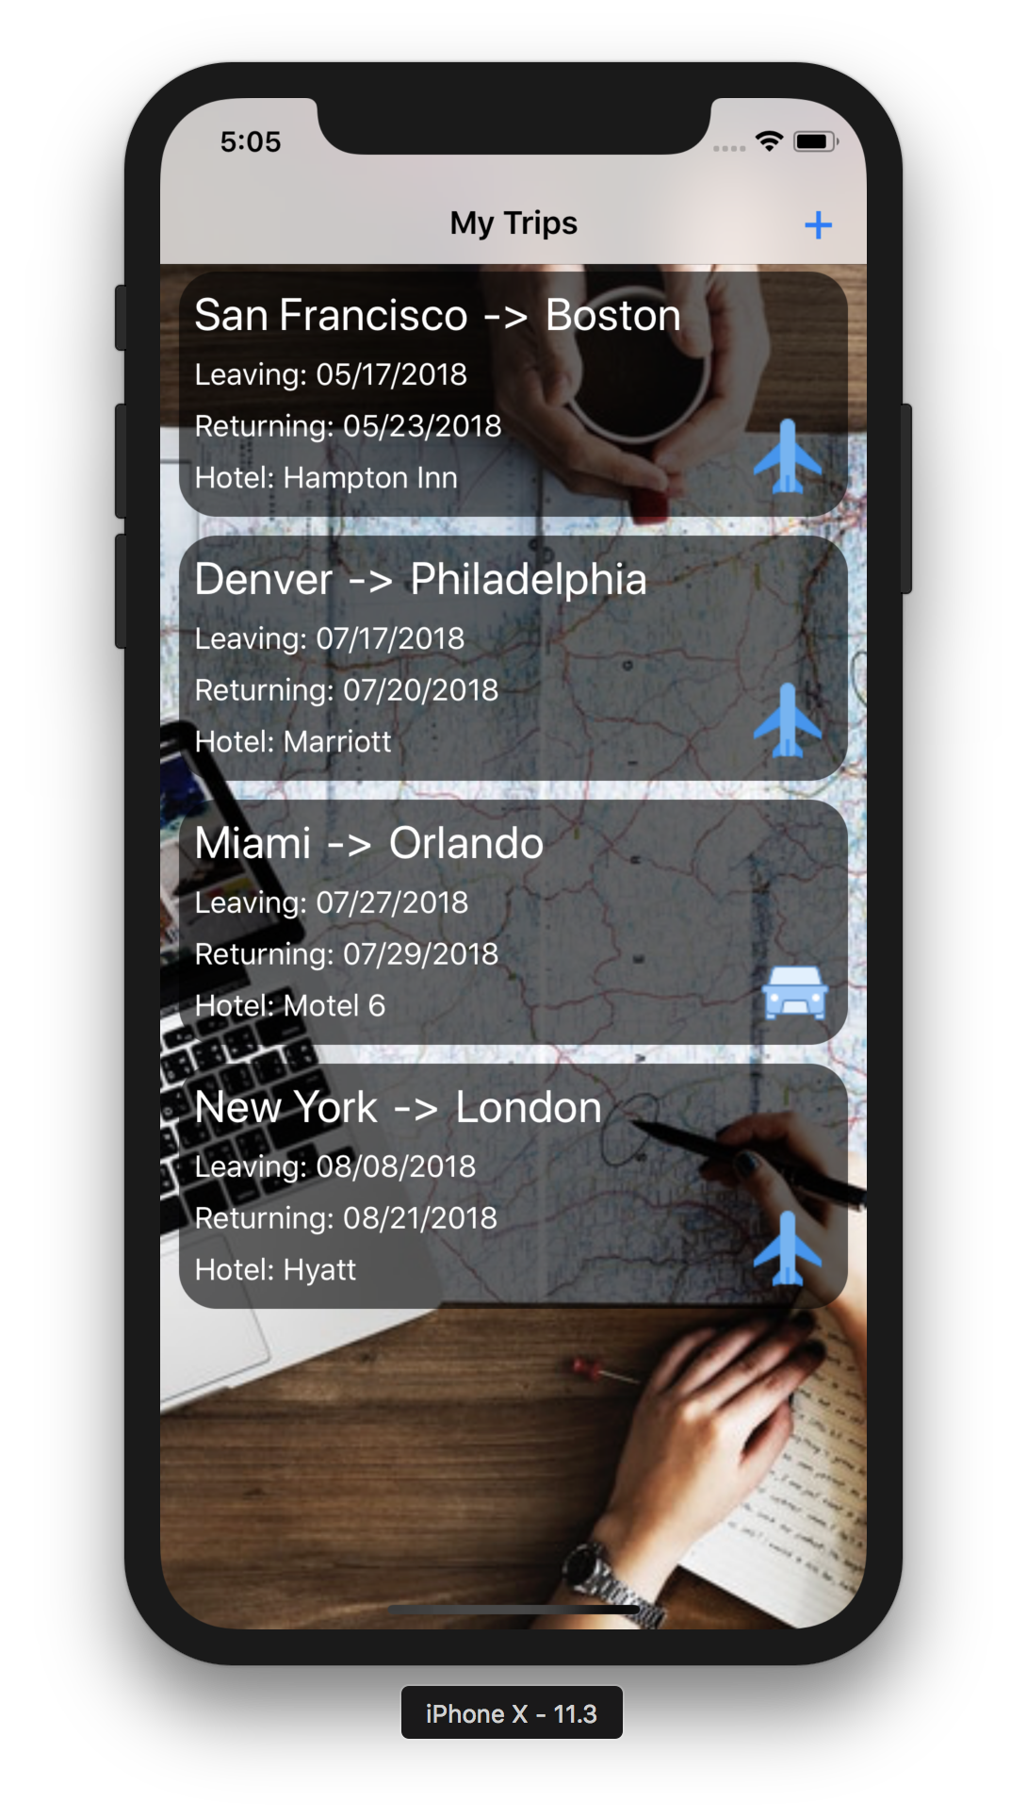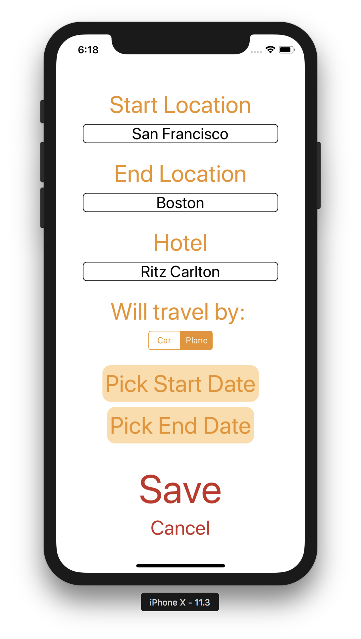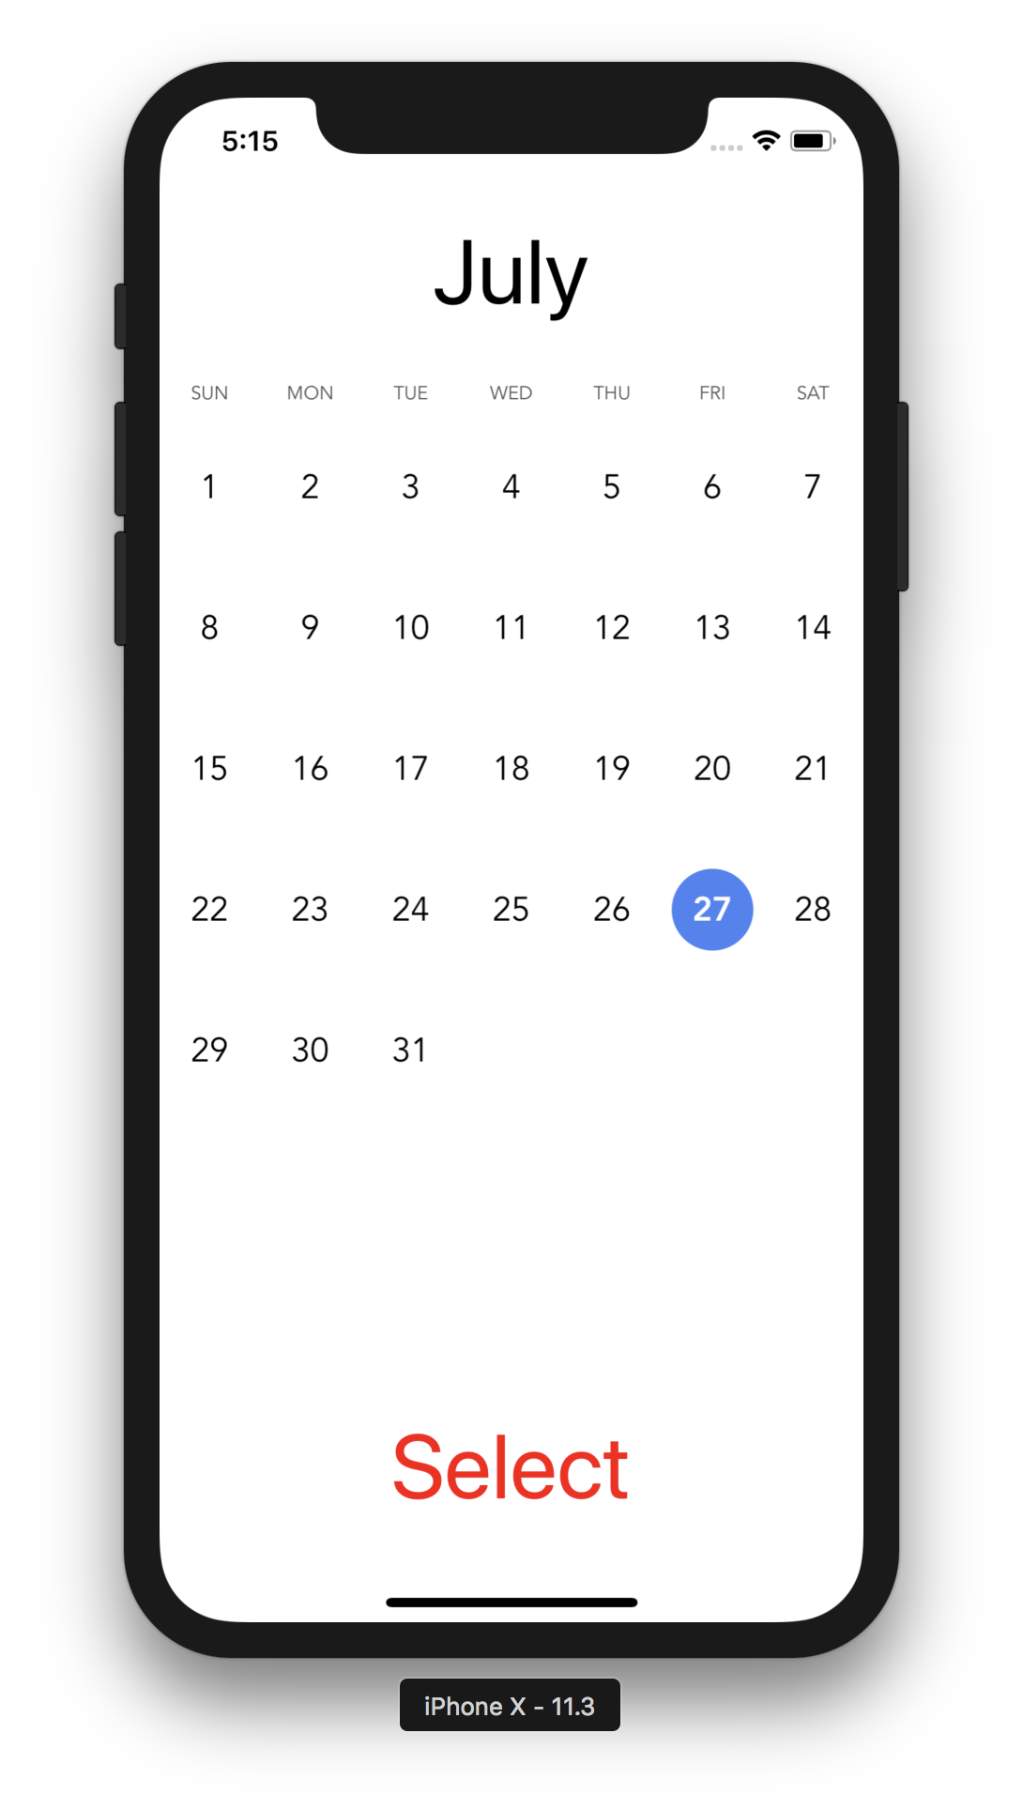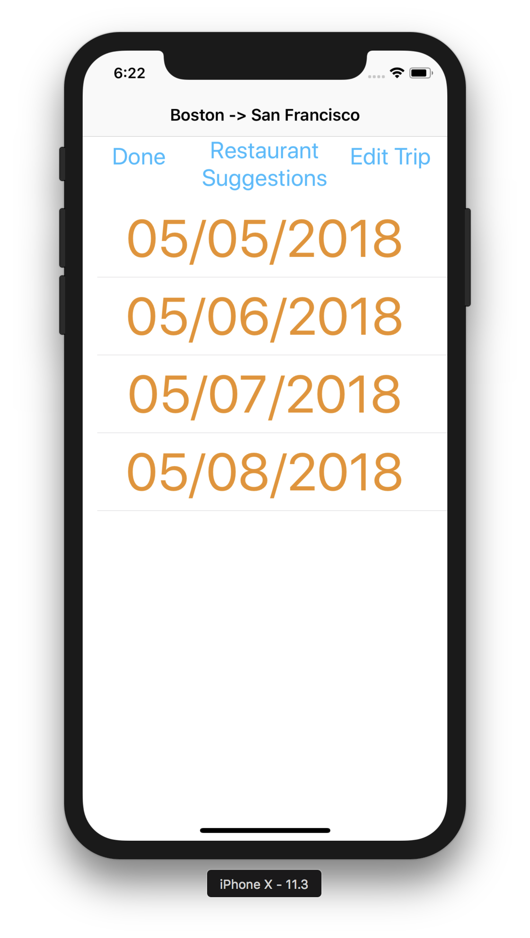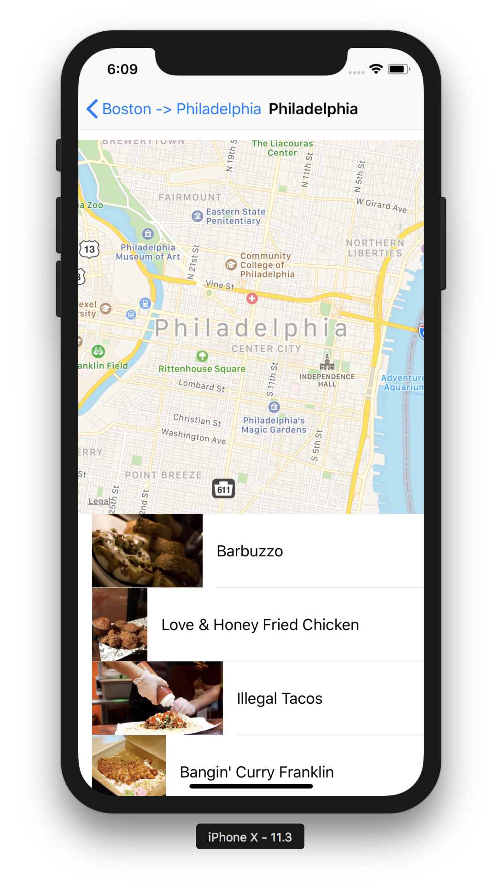

Short Description: Our app allows you to plan as many trips as you’d like. A trip includes a start location, an end location, a start date, an end date, a hotel, and a trip type (plane vs car). Once you’ve created a trip, you can edit your start and end dates, see a timeline of which days you’re away, and see a map of your destination city. Additionally, the app can recommend restaurants in your destination city.

How app addresses requirements:

Autolayout: Uses SnapKit for layouts

CollectionView or TableView: Home page is a CollectionView, many TableViews used throughout

Navigation: Lots of ViewControllers connected with NavigationController

API: API’s used for map and restaurant suggestion functionanility